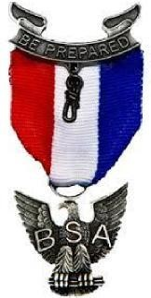**Northampton District**

**Minsi Trails Council**

Date: ______________

To: __________________________________

From: Eagle Candidate_______________________________________

Subject: Recommendation Request

I am a candidate for the rank of Eagle Scout, the highest award of

Scouting America, and request that you provide a letter of recommendation for me.

Please send your recommendation letter to James Daley, Northampton District Eagle Board of Review Chair, 475 East Lawn Road, Nazareth, PA 18064. Please mark the envelope personal and confidential. This letter **will not** be shared with me.

The honor proposed to be conferred upon me necessitates frank opinions of fellow citizens regarding my character and ability.

When I joined Scouting, I took an Oath – “On my honor I will do my best to do my duty to God and my country and to obey the Scout Law; to help other people at all times; to keep myself physically strong, mentally awake and morally straight.” The Scout Law referred to above is: A Scout is Trustworthy, Loyal, Helpful, Friendly, Courteous, Kind, Obedient, Cheerful, Thrifty, Brave, Clean and Reverent.

If you would advise Mr. Daley on how you believe I live up to the Scout Oath and Law it would be a great help in moving the process forward for me to earn my Eagle Scout Award.

A quick response would be appreciated as the letter of recommendation is a vital component to the board of review process.

Thank you for your consideration.

**(Candidate Signature)**

