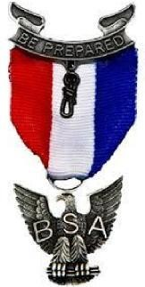**Monroe District**

**Minsi Trails Council**

Date: ______________

To: __________________________________

From: Eagle Candidate_______________________________________

Subject: Recommendation Request

I am a candidate for the rank of Eagle Scout, the highest award of

Scouting America, and request that you provide a letter of recommendation for me.

Please send your recommendation letter to Mark Kresge, 2865 Laurel Lane, Henryville, PA 18332. Please mark the envelope personal and confidential. This letter **will not** be shared with me.

The honor proposed to be conferred upon me necessitates frank opinions of fellow citizens regarding my character and ability.

When I joined Scouting, I took an Oath – “On my honor I will do my best to do my duty to God and my country and to obey the Scout Law; to help other people at all times; to keep myself physically strong, mentally awake and morally straight.” The Scout Law referred to above is: A Scout is Trustworthy, Loyal, Helpful, Friendly, Courteous, Kind, Obedient, Cheerful, Thrifty, Brave, Clean and Reverent.

If you would advise Mr. Kresge on how you believe I live up to the Scout Oath and Law it would be a great help in moving the process forward for me to earn my Eagle Scout Award.

A quick response would be appreciated as the letter of recommendation is a vital component to the board of review process.

Thank you for your consideration.

**(Candidate Signature)**

