2026 Membership Growth Plan
#502

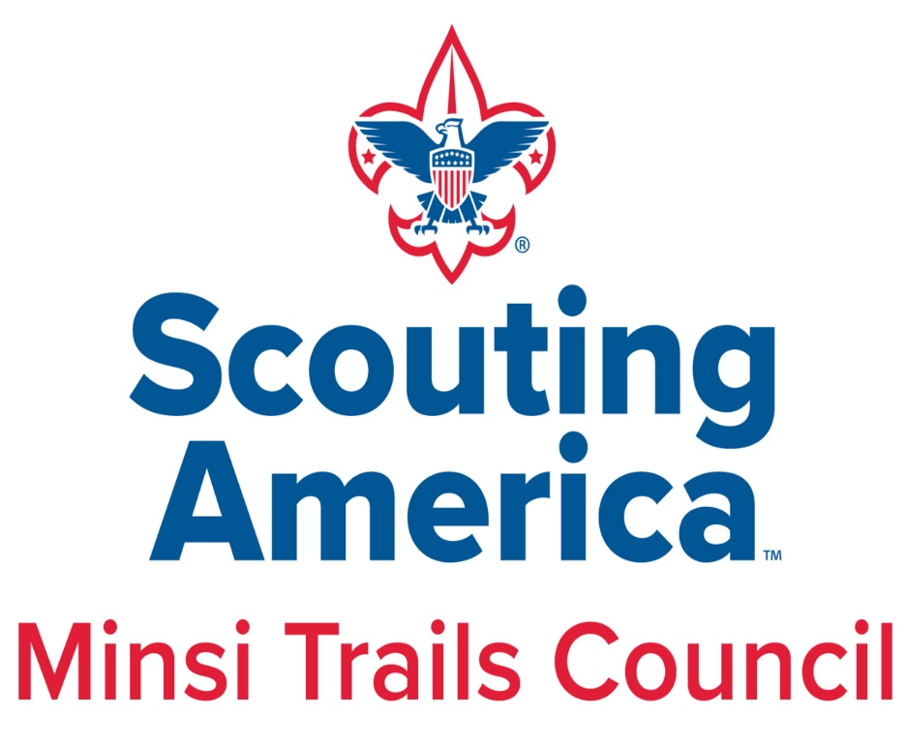

Table of Contents
Executive Summary 2
Council Membership Analysis 2-7
Council Background 2
Membership History and Market Share 3
New Youth Recruited and Retention 4
Unit History 5
Demographics 6
Ethnic Makeup 7
Assumptions 8
Plan for Membership Growth 9-12
Pillar 1 – Governance and Leadership Capacity 9
Pillar 2 – Access, Pipeline, and Community Presence 9
Pillar 3 – Membership Growth, Experience, and Retention 10-11
Pillar 4 – New Unit Sustainability, Exploring and Unit Health 12
Council Membership Goals 13
Establishing a Membership Committee 14-17
Timeline 18-21
Marketing Plan 22-27
Funnel Strategy 22
Spring Recruitment Campaign 23-24
Fall Recruitment Campaign 24-25
Dynamic Campaign 25
Target and Communication Channels 26-27
Unit Engagement and Metrics 27
Closing Remarks 28
Attachments 29-36
Approval of Membership Plan 30
District Membership Goals 31-33
Marketing Funnel (Visual) 34
Membership Committee Organizational Chart 35
Budget 36
EXECUTIVE SUMMARY
The 2026 Membership Plan is aligned with the Membership Pillar of the Council’s three-year strategic plan and is designed to drive sustainable growth through a volunteer-led, professionally guided approach. Building on prior year analysis, the plan outlines clear actions to expand Scouting’s reach and strengthen the member experience across all programs.
Key priorities include recruiting new youth, improving retention through strong programs and trained leaders, establishing new units in underserved areas, strengthening struggling units, building a coordinated council wide membership structure, and expanding access, diversity, and inclusion among youth and volunteers.
COUNCIL MEMBERSHIP ANALYSIS
Council Background
The Minsi Trails Council was formed in 1969 and, since then, has undergone many changes in district structures. 2020 was the most recent district restructuring, and each district was renamed to represent the county or counties served within the council boundaries. Currently, the Minsi Trails Council serves Carbon, Lehigh, Monroe, Northampton and parts of Luzerne Counties in Pennsylvania, along with Warren County, New Jersey. The Council Field Service territory is broken into two service areas: the Lehigh Valley Service Area, which encompasses Northampton District, Lehigh District, and Warren District; and the North Mountain Service Area, which encompasses Monroe District and Carbon-Luzerne District.
The Council’s Mission Statement is”
“… to serve others by helping to instill values in young people and in other ways prepare them to make ethical choices over their lifetime in achieving their full potential. The values we strive to instill are based on those found in the Scout Oath and Law.”
The Council’s Vision is:
“To grow Scouting in our Communities through each one of our charter partner relationships by, putting kids in Dens, Dens in Packs, Packs in every one of our community organizations.”

Membership History
The year-end membership totals, by program, for the last six years is as follows:
Year | Cub Scouts | Scouts BSA | Venturers | Explorers | Total
2020 | 3,248 | 2,561 | 241 | 462 | 6,512
2021 | 2,099 | 2,431 | 85 | 51 | 4,666
2022 | 2,071 | 2,248 | 69 | 85 | 4,473
2023 | 2,031 | 2,058 | 57 | 110 | 4,256
2024 | 2,102 | 1,937 | 51 | 124 | 4,214
2025 | 1,734 | 1,806 | 28 | 148 | 3,716

Market Share
As of the 2025 Market Analysis ReportThe Target Age Youth (TAY) in our council area is 153,768 across all programs. In market share, Minsi Trials Council ended at 2.41% overall; segmented below:
Program | TAY | Market Share
Cub Scout | 73,553 | 2.36%
Scouts BSA | 38,956 | 4.64%
Older Youth | 41,259 | 0.43%
Total | 153.768 | 2.41%

The council’s market share of females by program as of December 31, 2025, is as follows:
Program | Registered | TAY | Market Share
Cub Scouts | 268 | 73,553 | 0.36%
Scouts BSA | 232 | 39,476 | 0.58%
Older Youth | 47 | 41,465 | 0.11%
Total | 547 | 153,768 | 0.36%
New Scouts Recruited
As of 12/31/2025, the last six years of recruitment effort by program are shown below.
Year | Cub Scouts | Scouts BSA | Venturers | Explorers | Total
2020 | 238 | 105 | 10 | 26 | 379
2021 | 710 | 167 | 20 | 8 | 905
2022 | 689 | 171 | 12 | 46 | 918
2023 | 692 | 135 | 8 | 38 | 873
2024 | 659 | 138 | 9 | 50 | 856
2025 | 601 | 157 | 3 | 65 | 826

As an additional resource, we identified the number of new girls being recruited by the program, segmented as follows:
Year | Cub Scouts | Scouts BSA | Venturers | Explorers | Total
2020 | 34 | 37 | 6 | 11 | 88
2021 | 98 | 43 | 10 | 2 | 153
2022 | 105 | 41 | 7 | 8 | 161
2023 | 112 | 31 | 1 | 10 | 154
2024 | 122 | 40 | 4 | 13 | 179
2025 | 99 | 48 | 0 | 16 | 163

Retention
Below are the retention numbers by program for the last six years
Program | 2020 | 2021 | 2022 | 2023 | 2024 | 2025
Cub Scouts | 61.09% | 45.44% | 72.92% | 72.08% | 84.82% | 51.30%
Scouts BSA | 80.31% | 81.97% | 81.57% | 84.54% | 97.51% | 84.24%
Older Youth | 76.86% | 20.52% | 73.56% | 89.80% | 96.00% | 32.67%
Total | 68.74% | 58.66% | 77.49% | 78.77% | 74.07% | 65.71%

Unit History
Segmented below is the 6-year analysis of the total number of units by program.
Units Overall | Packs | Troops | Crews/Ships | Posts/Clubs | Total
2020 | 119 | 128 | 15 | 15 | 277
2021 | 86 | 122 | 14 | 7 | 229
2022 | 79 | 116 | 12 | 6 | 213
2023 | 72 | 113 | 9 | 6 | 200
2024 | 73 | 111 | 10 | 7 | 200
2025 | 70 | 107 | 9 | 7 | 193

In addition to overall units by year and program, we identified the number of new units that were developed versus the number of units dropped; segmented in two separate tables below.
New Units | Packs | Troops | Crews/Ship | Post/Club | Total
2020 | 0 | 0 | 0 | 0 | 0
2021 | 1 | 0 | 0 | 0 | 1
2022 | 2 | 4 | 1 | 2 | 9
2023 | 4 | 3 | 1 | 1 | 9
2024 | 2 | 3 | 2 | 1 | 8
2025 | 1 | 1 | 0 | 0 | 2

Dropped Units | Packs | Troops | Crews/Ship | Post/Club | Total
2020 | 23 | 6 | 4 | 5 | 38
2021 | 33 | 6 | 1 | 8 | 48
2022 | 9 | 9 | 4 | 2 | 24
2023 | 11 | 6 | 3 | 1 | 21
2024 | 2 | 5 | 1 | 0 | 8
2025 | 5 | 5 | 1 | 0 | 11

Demographics
There are 107 ZIP codes that make up the Minsi Trails Council that have been mapped out and analyzed for key demographic insight and lifestyle segmentation analysis to correspond to the fifty-one (51) population segments listed in the Experian Mosaic Segment Guide. There are twenty (20) dominant segments in our council area, distributed as follows:
Dominant Mosaic Segment Number | Dominant Mosaic Segment Description | Number of Zip Codes
J34 | Suburban Sophisticates | 28
E21 | Unspoiled Splendor | 24
J36 | Settled and Sensible | 8
Q64 | Established Society | 7
C13 | Philanthropic Sophisticates | 7
D16 | Settled in Suburbia | 5
C11 | Sophisticated City Dwellers | 5
L41 | Booming and Consuming | 3
I30 | Potlucks and the Great Outdoors | 3
B07 | Across the Ages | 3
D15 | Sports Utility Families | 2
E20 | No Place Like Home | 2
J35 | Rural Escape | 2
H29 | Destination Recreation | 2
O51 | Digitally Savvy | 1
P59 | Expanding Horizons | 1
H27 | Life of Leisure | 1
A05 | Couples with Clout | 1
K37 | Wired for Success | 1
L43 | Homemade Happiness | 1

A whole Demographic and Income Profile with five-year projections for our council area is attached to the end of this document.
The top 10 Mosaic Segments that the council is currently serving are as follows:
Mosaic Description |  | Cub Scout Members | % of Cub Scout Members | Households in the Council Area | % of Households in Council Area | Index
D15 | Sports Utility Families | 170 | 9.5% | 24,471 | 5.6% | 1.7
D16 | Settled in Suburbia | 165 | 9.2% | 11,655 | 2.7% | 3.4
I30 | Potluck and the Great Outdoors | 89 | 5.0% | 11,399 | 2.6% | 1.9
H27 | Life of Leisure | 80 | 4.5% | 7,360 | 1.7% | 2.6
A05 | Couples with Clout | 76 | 4.2% | 5,394 | 1.2% | 3.4
C13 | Philanthropic Sophisticates | 76 | 4.2% | 14,504 | 3.3% | 1.3
B07 | Across the Ages | 67 | 3.7% | 9,070 | 2.1% | 1.8
A04 | Picture Perfect Families | 66 | 3.7% | 10,712 | 2.5% | 1.5
F22 | Fast Track Couples | 62 | 3.5% | 8,413 | 1.9% | 1.8
I31 | Hard Working Values | 57 | 3.2% | 12,898 | 3.0% | 1.1

The index shows how well the council's Scouting membership matches the population. An index of 1.0 indicates it matches the population perfectly. An index above 1.0 indicates the council is serving a greater percentage than the population; whereas an index below 1.0 indicates a lower rate of population served.
Ethnic Makeup
Below is an explanation of the council membership breakdown by ethnicity. Please note that among the council’s youth members, 2.6% do not have an ethnic code in the database.
Ethnicity | % of Youth Members | % of TAY | Member - TAY Difference
Hispanic/Latino | 7.7% | 22.9% | -15.2%
African American | 3.1% | 6.9% | -3.7%
Asian | 3.9% | 3.1% | +0.8%
Caucasian | 82.1% | 63.9% | +18.2%
Other | 5.2% | 3.3% | -0.1%

ASSUMPTIONS
- By 2026, we can expect the following demographic trends to occur in our Council:
  - The population of the area will remain relatively constant, with an increase in the overall population of +1.3%
  - The Cub Scout Target Age Youth to decrease by -0.86% to 72,920.
  - Both Urban and Rural Population will increase to +2.2%; Rural (+0.8%) and Urban (+1.4%).
  - An increase in the overall Ethnic Population:
    - Mixed (Two or More Races) will increase by +15.3%
    - Asian will increase +10.1%
    - Hispanic/Latino will increase +9.1%
  - There will be a decrease in the Caucasian Population of -2.4%
- The Minsi Trails Council will remain fiscally viable.
- The Minsi Trails Council will provide top-quality service to all units.
- The Minsi Trails Council Membership Committee will be developed.
- Retention in the Scouting program will continue at or near present levels.
- The Minsi Trails Council will “turn the corner” and reverse the downward trend of market share across the programs.

Plan for Membership Growth
Purpose
The purpose of the 2026 Membership Plan is to grow Scouting in Minsi Trails Council through disciplined execution, equitable access, and sustainable unit development. Building on the foundation established in prior years, 2026 will focus on increasing market share, strengthening retention, expanding access for underserved populations, and ensuring every unit and program is healthy and supported.
Strategic Framework for 2026
The 2026 Membership Plan is organized around four strategic pillars:
- Governance and Leadership Capacity
- Access, Pipelines, and Community Presence
- Membership Growth, Experience, and Retention
- New Unit Sustainability, Exploring, and Leader Health
Clear ownership is assigned to ensure accountability:
• Volunteer Committees (Red) lead relationships and advocacy
• Commissioners (Purple) ensure unit health, onboarding, and retention
• Staff (Green) own execution, access, and sustainability
• Blended indicates shared responsibility with defined handoffs
Pillar 1: Governance and Leadership Capacity
Formal District Recruitment Subcommittees
Ownership: Volunteer Committees with Staff Support
By December 31, 2026, each district will establish a formally chartered District Recruitment Subcommittee with clearly defined roles, including a chair, a school access lead, a recruitment event coordinator, and a new unit development lead.
Success indicators include active subcommittees in all districts, quarterly action plans, and a minimum of two recruitment actions per district by semester.
Commissioner Capacity and New Leader Support
Ownership: Commissioners
By December 31, 2026, Unit Commissioner ranks will increase by 25 percent, with a focus on packs with new leadership and newly established units. Commissioners will provide immediate onboarding support and participate in membership reviews during rechartering.
Success indicators include commissioner assignment within 30 days of new leader registration and improved first-year retention.
Pillar 2: Access, Pipelines, and Community Presence
Council wide Master Access and Recruitment Calendar
Ownership: Staff
By May 1, 2026, the council will maintain a live digital master calendar that includes school open house dates, flyer policies, spring and fall recruitment windows, and key membership milestones. This system will ensure no recruitment opportunities are missed due to access barriers.
Diversified Recruitment Pipelines
Ownership: Blended
Each district will establish active relationships with pre-kindergarten programs, Head Start agencies, after-school programs, and community organizations to diversify entry points into Scouting beyond traditional school nights.
By the end of 2026, at least 20 percent of new Cub Scout families will originate from non-school recruitment channels.
School Ambassador Program
Ownership: Volunteer Committees
By August 31, 2026, the council will recruit and train at least 40 School Ambassadors to serve as liaisons between units, schools, and parent organizations. Priority will be given to schools located in high-opportunity ZIP codes.
Pillar 3: Membership Growth, Experience, and Retention
Council Membership and Scout Reach Outcomes
Ownership: Staff with Blended Support
By December 31, 2026, the council will serve 4,000 youth while ensuring Scout Reach remains an intentional access strategy rather than an isolated program. Staff will identify Scout Reach eligible schools and communities, provide financial and programmatic support, and work to transition Scout Reach units into sustainable community-based models when possible.
Targeted Growth: Hispanic and Female Youth
Ownership: Staff with Volunteer Support
The council will increase market share to 1.00 percent for both Hispanic or Latino youth and female youth through targeted ZIP-code-based recruitment, bilingual outreach, and intentional recruitment and training of female leaders.
Program Transparency and Youth-Led Recruitment
Ownership: Blended
By August 2026, at least 90 percent of packs will publish annual calendars prior to fall recruitment. The council will implement a youth-led recruitment initiative that encourages Scouts to invite friends to fun activities rather than traditional meetings.
Cub Scout Retention Rate
Ownership: Blended
By December 2026, we will turn the tide on declining membership through retention by attaining a month-to-month
rate of 74% retention overall with an emphasis on 85% in Cub Scouts.
Pillar 4: New Unit Sustainability, Exploring, and Leader Health
Leaders-First Model for All Units and Programs
Ownership: Staff and Commissioners
No new unit or program will launch unless a full leadership team is recruited, trained, supported by a commissioner, and equipped with a first-year program calendar.
The council will maintain a 90 percent survival rate for new units and programs at 24 months.
Exploring Expansion
Ownership: Staff
By December 31, 2026, the council will expand Exploring opportunities with a focus on law enforcement, fire and EMS, skilled trades, and emerging workforce sectors. Each service area will have at least one active Exploring opportunity, with a designated staff leader responsible for growth and sustainability.
New Unit Development
Ownership: Blended
By December 31, 2026, the Minsi Trails Council will develop 10 new Cub Scout Packs in growth opportunity areas identified by district.

Charter Partner Integration and Sustainability
Ownership: Volunteer Committees
Every unit will complete at least one annual service project for its charter partner to strengthen relationships and position Scouting as a true community partner. Districts will host cultivation events for current and prospective charter partners to support long-term unit growth.
Summary Statement
By executing this plan, Minsi Trails Council will grow to serve 4,000 youth through disciplined systems, expanded access, strong volunteer leadership, and sustainable unit development, ensuring Scouting remains relevant, inclusive, and impactful across the council.

2026 Minsi Trails Council Goals
2026 New Youth Recruited - Monthly Goals
 | Carbon/Luzerne | Lehigh | Monroe | Northampton | Warren |  | MTC
January | 5 | 5 | 7 | 7 | 1 |  | 25
February | 5 | 23 | 5 | 10 | 3 |  | 46
March | 5 | 30 | 10 | 45 | 5 |  | 95
April | 3 | 15 | 10 | 10 | 15 |  | 53
May | 10 | 15 | 12 | 20 | 10 |  | 67
June | 3 | 10 | 5 | 5 | 1 |  | 24
July | 0 | 10 | 0 | 5 | 5 |  | 20
August | 3 | 30 | 12 | 25 | 10 |  | 80
September | 20 | 90 | 45 | 75 | 38 |  | 268
October | 5 | 80 | 45 | 60 | 20 |  | 210
November | 2 | 30 | 15 | 32 | 5 |  | 84
December | 10 | 10 | 5 | 10 | 5 |  | 40
Total | 71 | 348 | 171 | 304 | 118 |  | 1012
2026 Minsi Trails Council Total Youth Goals
 | 2025 Actual | 2026 Goal
Lions | 192 | 200
Tigers | 262 | 269
Cub Scouts | 600 | 610
Webelos | 430 | 437
Arrow of Light | 250 | 255
Total Cub Scouts | 1,734 | 1,771
Scouts BSA (Boys) | 1,574 | 1560
Scouts BSA (Girls) | 232 | 255
Total Scouts BSA | 1,806 | 1815
Venturing | 20 | 20
Sea Scouting | 8 | 10
Exploring | 148 | 160
Total Older Youth Program | 176 | 190
Total Council Membership | 3,716 | 3,776
Market Share | 2.41% | 2.45%

Total Units Goal
Packs | 70 | 75
Troops (Boys) | 107 | 100
Crews/Ships | 9 | 9
Post | 7 | 9
Total Units | 193 | 193

Council Membership Committee – Structure & Collaborative Function
The Council Membership Committee serves as the central engine—the cogmachine—those drives coordinated, council-wide membership growth. Structured to ensure clarity of leadership, alignment of responsibilities, and seamless collaboration across all service areas, the committee operates under a volunteer-driven, professionally guided model consistent with the 2026 Membership Plan priorities.
Committee Structure
At the council level, the committee is organized under an Executive Vice President (EVP) of Membership, who provides strategic direction, monitors district performance, and ensures the execution of council membership initiatives. The EVP of Membership is supported by:
Council Membership Team
- Council Staff Advisor
Provides professional guidance, coordination, and operational support.
- Council Vice President of Membership
Oversees action teams, ensures system consistency, and coordinates cross-functional membership work.
- Cub Scout Action Team
A volunteer team focused on Cub Scout recruitment, transitions, new unit development, and renewals.
- Scouts BSA Action Team
Supports troop growth, recruitment campaigns, transitions, program readiness, and unit service needs.
- Educational Services Relationship Team
A team of educators who help gain school access, interpret flyer and presentation rules, and remove barriers for units.
- Charter Partner Relationships Team
Supports the cultivation, stewardship, and onboarding of charter partners.
District-Level Structure
Each district maintains:
- District Membership Chair
Leads district-level recruitment, coordinates sub-committees, supports unit-level needs, and executes the district’s membership calendar.
- District Recruitment Subcommittee
Includes school access leads, recruitment event coordinators, and new-unit development leads.
Each subcommittee is responsible for building out quarterly action plans and executing a minimum of two recruitment actions per semester.
Overall Focus of the Membership Committee
The Membership Committee’s central purpose is to establish, manage, and sustain a coordinated, year-round membership system that increases access, strengthens retention, and ensures high-quality program delivery across all districts. The committee focuses on:
- Recruitment: Spring, fall, and dynamic year-round strategies using school access, community partnerships, and program-driven engagement.
- Retention: Monitoring membership health, supporting transitions, and aligning with commissioners to secure strong unit onboarding and first-year success.
- New-Unit Development: Identifying growth ZIP codes, preparing leaders-first structures, and supporting emerging charter partners.
- Access & Equity: Building pipelines for underserved communities, strengthening ScoutReach, and supporting bilingual and female-led recruitment channels.
The Cogmachine: Collaboration & Cross-Functional Integration
The Membership Committee does not operate in isolation, its success depends on deep, intentional collaboration with other key areas of the council. These partnerships ensure that every membership action is supported operationally, programmatically, and relationally.
Marketing Committee
Provides branding, digital campaigns, flyers, social media outreach, and recruitment messaging.
Supports the membership funnel (awareness → interest → engagement → conversion).
Program Committee
- Ensures program quality, meeting calendars, and program readiness—critical for both retention and recruitment.
- Helps align events (Pinewood Derby previews, camp promotions, troop open houses) with membership campaigns.
Commissioner Corps
- Provides onboarding, unit service, retention follow-up, and membership health assessments.
- Supports new leaders and ensures units are prepared to retain youth and deliver high-quality experiences.
ScoutReach
- Ensures equitable access for underserved communities.
- Coordinates staff-led and volunteer-supported efforts within access-priority ZIPs.
- Integrates with membership to align recruitment opportunities and program support.
Relationships (Charter Partners & External Organizations)
- Strengthens and sustains charter partner relationships.
- Expands partnerships with schools, community organizations, youth-serving agencies, and civic groups.
- Coordinates with membership to identify new unit opportunities and access points.

Timeline
January: Planning and Readiness
Primary focus: preparation and access control
• Train spring recruitment manpower in preparation for February kickoff
• Identify packs offering summer programs and confirm calendars
• Finalize new unit prospect list
• Schedule 50 percent of school career surveys
• Finalize Spring recruitment plans
• Identify Scout Reach, DEI, and Scouts with Disabilities priority schools
• Begin AOL to Scout transition identification
February: Commitment and Transition Launch
Primary focus on readiness and transitions
• Conduct Unit Willing and Able surveys
• Draft unit spring recruitment goals
• Conduct school career surveys
• Complete two new unit sales calls per district
• Host Spring Recruitment Kickoff and Training on February 17
• Begin AOL to Scout transition conversations
• Secure unit commitments for spring recruitment
March: Spring Recruitment Begins
Primary focus on execution and momentum
• Launch Spring Recruitment
• Conduct Spring recruitment events
• Secure remaining spring recruitment dates
• Plan Save-A-Scout phonathon
• Complete two new unit sales calls per district
• Continue AOL to Scout transition planning
April: Spring Recruitment and Retention
Primary focus on recruitment and transitions
• Continue Spring Recruitment events
• Conduct community recruitment events
• Schedule 50 percent of school administrator visits
• Execute Save-A-Scout retention effort
• Complete two new unit sales calls per district
• Conclude AOL to Scout transition by the end of April
• Draft fall recruitment framework
May: Spring Closeout and Fall Launch
Primary focus on handoff and preparation
• Complete Spring Recruitment cycle
• Meet or exceed spring recruitment goals
• Host Fall Recruitment Kickoff and Training in May
• Begin school administrator visits
• Recruit district and unit fall recruitment chairs
• Schedule 100 percent of school administrator visits
• Complete two new unit sales calls per district
• Launch Lion Recruitment (Pre-K–K)

June: Lion Recruitment and Fall Readiness
Primary focus: Lions and access
• Continue Lion Recruitment (May–June)
• Complete 50 percent of school administrator meetings
• Finalize fall recruitment plans and calendars
• Finalize unit fall membership goals
• Complete two new unit sales calls per district
• Conduct follow-up fall recruitment training
July: Summer Engagement
Primary focus on visibility and relationship building
• Complete 75 percent of school administrator visits
• Finalize fall kickoff events and schedules
• Confirm unit fall membership goals
• Conduct summer community recruitment events
• Complete two new unit sales calls per district
• Finalize Exploring fall recruitment opportunities
August: Fall Recruitment Launch
Primary focus, maximum opportunity
• Launch Fall Recruitment
• Complete 100 percent of school administrator visits
• Schedule at least 50 percent of unit recruitment nights
• Schedule at least 50 percent of back-to-school nights
• Complete two new unit sales calls per district
• Finalize Scout Reach school-based recruitment support
September: Peak Fall Recruitment
Primary focus volume and conversion
• Conduct 50 percent of school talks by September 15
• Complete 50 percent of sign-up nights by September 15
• Finalize community recruitment events by September 30
• Schedule second-round sign-up nights
• Promote troop and crew open houses
• Complete two new unit sales calls per district
October: Fall Follow-Up
Primary focus second chance recruitment
• Complete 100 percent of first-round sign-up nights by October 15
• Complete 50 percent of second-round sign-ups by October 15
• Schedule all second-round events by October 31
• Complete two new unit sales calls per district
• Commissioner focus on new leader and new unit support
November: Fall Recruitment Close
Primary focus evaluation and transition
• Conclude Fall Recruitment by mid-November
• Review fall recruitment results by November 15
• Organize all new units and complete leadership onboarding
• Complete two new unit sales calls per district
• Finalize retention follow-up for new families
• Review Exploring sustainability
December: Close Out and Reset
Primary focus results and forward planning
• Confirm year-end membership totals
• Review and refine new unit prospect lists
• Secure Spring recruitment manpower for the next year
• Review retention, Scout Reach, DEI, and Lion outcomes
• Draft district growth goals for the following year
• Secure crossover dates and unit calendars

Marketing Plan
The 2026 Membership Marketing Plan establishes a coordinated strategy to grow youth participation across the Minsi Trails Council through targeted recruitment campaigns, strategic communication, and data driven marketing efforts. The plan integrates spring recruitment, fall recruitment, and dynamic year round recruitment to support the council's membership growth objective.
The plan focuses on three core priorities.
Increase visibility of Scouting across the council territory
Improve conversion of interested families into registered members
Expand outreach into underserved markets and high opportunity geographic areas
Marketing Funnel Strategy
The council will implement a structured marketing funnel to move families from awareness to registration.
The funnel is designed to generate a sufficient volume of interest and engagement opportunities that ultimately convert to new youth registrations.
Awareness
Parents become aware of Scouting programs through school partnerships, community visibility, and digital marketing.
Interest
Families seek additional information through QR codes, website visits, and interest forms.
Engagement
Families attend recruitment events such as join nights, pack meetings, troop open houses, or program demonstrations.
Conversion
Youth complete the registration process and become members of a local unit.
The funnel is designed to support the following activity levels.
Approximately forty-five thousand families reached through marketing efforts
Approximately three thousand interested families requesting information
Approximately sixteen hundred families attending recruitment events
Approximately one thousand new youth registrations
This structured funnel approach allows the council to track marketing performance and adjust recruitment strategies throughout the year.
Spring Recruitment Campaign
Spring recruitment focuses on engaging families who are seeking new activities prior to the summer season. The spring campaign also allows units to introduce new youth to Scouting before summer camp and outdoor activities begin.
Timeline
March 15 through May 31
Lion recruitment will continue through the month of June.
Spring Recruitment Goal
239 New Youth
Recruitment targets include the following.
Cub Scouts grades one through four
Lion Scouts kindergarten
Scouts BSA youth transitioning from elementary school into middle school
Spring marketing efforts will emphasize the following program benefits.
Outdoor adventure and camping
Hands on activities and learning
Leadership and character development
Preparation for summer camp programs
Primary marketing tactics include the following.
Distribution of school flyers
Digital promotion through Facebook and social media
Unit hosted recruitment events and activity nights
Council website promotion and online interest forms
Spring recruitment success will also be supported by strong follow up communication with interested families and invitations to upcoming pack and troop activities.
Fall Recruitment Campaign
Fall recruitment represents the largest membership growth opportunity of the year and will be supported through a comprehensive council wide marketing effort.
Timeline
August 15 through October 31
Additional registrations are expected through the month of November.
Fall Recruitment Goal
632 New Youth
Program recruitment targets include the following.
Five hundred new Cub Scouts grades kindergarten through fifth grade
Eighty new Scouts BSA youth grades six through high school
Fifty new Exploring youth in high school
The fall campaign will focus heavily on back to school recruitment opportunities and community visibility.
Key marketing activities include the following.
School open house recruitment tables
Distribution of recruitment flyers in elementary schools
Community visibility through banners and yard signs
Social media advertising targeting parents of school age children
Recruitment nights hosted by packs and troops
Messaging during fall recruitment will emphasize the value of Scouting in helping youth build confidence, friendships, leadership skills, and a connection to the outdoors
Dynamic Year Round Recruitment
Dynamic recruitment refers to membership growth that occurs outside of the traditional recruitment seasons. Families often discover Scouting at different points throughout the year and the council will maintain a continuous marketing presence to capture these opportunities.
Dynamic recruitment will focus on three key strategies.
Maintaining an active digital presence through the council website and social media platforms
Encouraging units to regularly invite prospective families to attend meetings or activities
Leveraging community events, festivals, and public programs as opportunities to introduce Scouting to new families
This year round recruitment approach ensures that interested families can connect with Scouting at any time rather than waiting for a specific recruitment event.
Target Market Focus
Marketing efforts will prioritize geographic areas with high concentrations of youth who are not currently participating in Scouting programs.
Several ZIP codes within the council territory contain significant numbers of unserved youth and represent key opportunities for membership growth.
Marketing strategies in these communities will include increased school engagement, community partnerships, and targeted outreach campaigns.
The council will also focus on expanding participation among traditionally underserved populations to ensure Scouting reflects the diversity of the communities it serves.
Communication Channels
The council will utilize multiple communication platforms to effectively reach families.
School Partnerships
School relationships remain the most effective recruitment channel and will include flyer distribution, participation in school open houses, and direct engagement with school administrators.
Social Media
Facebook and Instagram will be used to promote recruitment events, highlight Scouting activities, and share program success stories.
Council Website
The council website will serve as the primary hub for recruitment information and will include program descriptions, unit locator tools, and registration resources.
Email Campaigns
Email communication will be used to follow up with interested families and provide invitations to recruitment events and program activities.
Community Visibility
Banners, yard signs, and community events will increase public awareness of Scouting programs.
Unit Engagement
Local units play a critical role in converting interested families into registered members.
The council will support units by providing recruitment toolkits, marketing templates, and training opportunities designed to help unit leaders conduct effective recruitment events.
Units will be encouraged to host engaging activities that allow prospective youth and parents to experience Scouting firsthand.
Examples include outdoor demonstrations, Pinewood Derby previews, camping demonstrations, and pack activity nights.
Marketing Performance Measurement
The council will track several key performance indicators to evaluate the effectiveness of marketing efforts.
Number of families reached through marketing campaigns
Website traffic and online inquiry submissions
Attendance at recruitment events
New youth registrations by program
Participation rates by district and unit
A membership dashboard will be used to monitor progress toward the council's goal of 1,012 new youth and to inform adjustments to marketing strategies throughout the year.

Closing Remarks
Execution and implementation.
This plan should be reviewed at the district level and be ready for implementation in January 2026. The District Chair, through the Council Vice President of District Operations, is responsible for ensuring that the districts comply with the provisions and timelines in this plan.
The Council Membership and Relations Committee will report on progress toward goals, by district and overall, for the Council, as outlined in the Council Strategic Plan.
The Council Vice President of Membership is responsible for reviewing this plan quarterly and revising it as needed.

Attachments
  - Approval by the Council Executive Board
  - District Membership Goals – 2026
  - Membership Marketing Funnel
  - Committee Organizational Chart
  - Budget

Attachment 1.
Approval by the Executive Board
At the meeting of the Minsi Trails Council Executive Board on March 23, 2026, this Council Membership Plan was approved for execution by the executive board with the following changes:

Submitted by: _____________________________________ ___________________
Dr. Peter Mayes, VP Membership Date
_____________________________________ ___________________
Vincent Polakowski, Membership Staff Advisor Date

Approved by: _____________________________________ ___________________
Llewellyn Dryfoos, Council President Date
______________________________________ ___________________
Kevin McClelland, Scout Executive Date

Attachment 2.
2026 Carbon/Luzerne District Goals (Year End)
 | 2025 Actual | 2026 Goal
Lions | 7 | 9
Tigers | 20 | 21
Cub Scouts | 52 | 53
Webelos | 43 | 44
Arrow of Light | 15 | 15
Total Cub Scouts | 137 | 142
Scouts BSA (Boys) | 129 | 125
Scouts BSA (Girls | 35 | 40
Total Scouts BSA | 164 | 165
Venturing | 0 | 0
Sea Scouting | 0 | 0
Exploring | 0 | 0
Total Older Youth Program | 0 | 0
Total District Membership | 301 | 307
Market Share | 1.73% | 1.78%

2026 Lehigh District Goals (Year End)
 | 2025 Actual | 2026 Goal
Lions | 78 | 80
Tigers | 93 | 95
Cub Scouts | 207 | 211
Webelos | 160 | 162
Arrow of Light | 100 | 102
Total Cub Scouts | 638 | 650
Scouts BSA (Boys) | 573 | 568
Scouts BSA (Girls | 57 | 67
Total Scouts BSA | 630 | 635
Venturing | 19 | 19
Sea Scouting | 4 | 6
Exploring | 66 | 70
Total Older Youth Program | 89 | 95
Total District Membership | 1,357 | 1,380
Market Share | 2.58% | 2.62%

2026 Monroe District Goals (Year End)
 | 2025 Actual | 2026 Goal
Lions | 25 | 26
Tigers | 54 | 56
Cub Scouts | 91 | 93
Webelos | 65 | 66
Arrow of Light | 46 | 47
Total Cub Scouts | 281 | 288
Scouts BSA (Boys) | 260 | 258
Scouts BSA (Girls | 69 | 73
Total Scouts BSA | 329 | 331
Venturing | 0 | 0
Sea Scouting | 4 | 0
Exploring | 0 | 0
Total Older Youth Program | 4 | 0
Total District Membership | 614 | 619
Market Share | 2.68% | 2.71%

2026 Northampton District Goals (Year End)
 | 2025 Actual | 2026 Goal
Lions | 53 | 55
Tigers | 61 | 63
Cub Scouts | 175 | 177
Webelos | 117 | 119
Arrow of Light | 67 | 68
Total Cub Scouts | 473 | 481
Scouts BSA (Boys) | 459 | 456
Scouts BSA (Girls | 42 | 45
Total Scouts BSA | 501 | 501
Venturing | 1 | 1
Sea Scouting | 0 | 4
Exploring | 82 | 90
Total Older Youth Program | 83 | 95
Total District Membership | 1,057 | 1,077
Market Share | 2.30% | 2.35%

2026 Warren District Goals (Year End)
 | 2025 Actual | 2026 Goal
Lions | 29 | 30
Tigers | 34 | 35
Cub Scouts | 75 | 76
Webelos | 45 | 46
Arrow of Light | 22 | 22
Total Cub Scouts | 205 | 209
Scouts BSA (Boys) | 153 | 153
Scouts BSA (Girls | 29 | 30
Total Scouts BSA | 182 | 183
Venturing | 0 | 0
Sea Scouting | 0 | 0
Exploring | 0 | 0
Total Older Youth Program | 0 | 0
Total District Membership | 387 | 392
Market Share | 2.54% | 2.57%

Attachment 3.
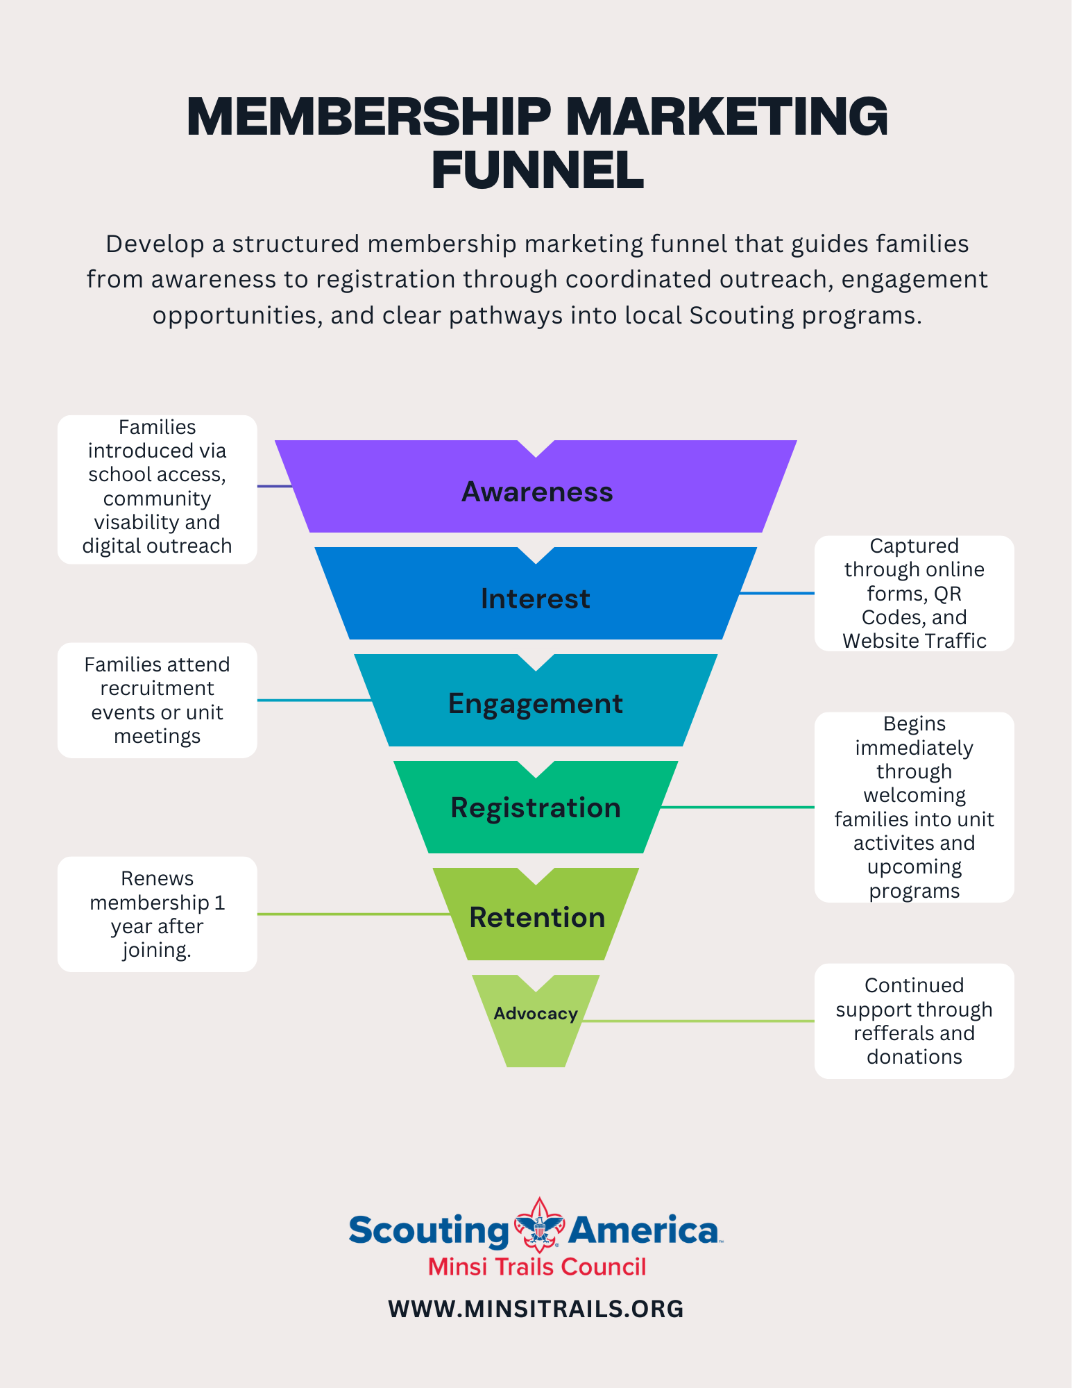
Attachment 4.

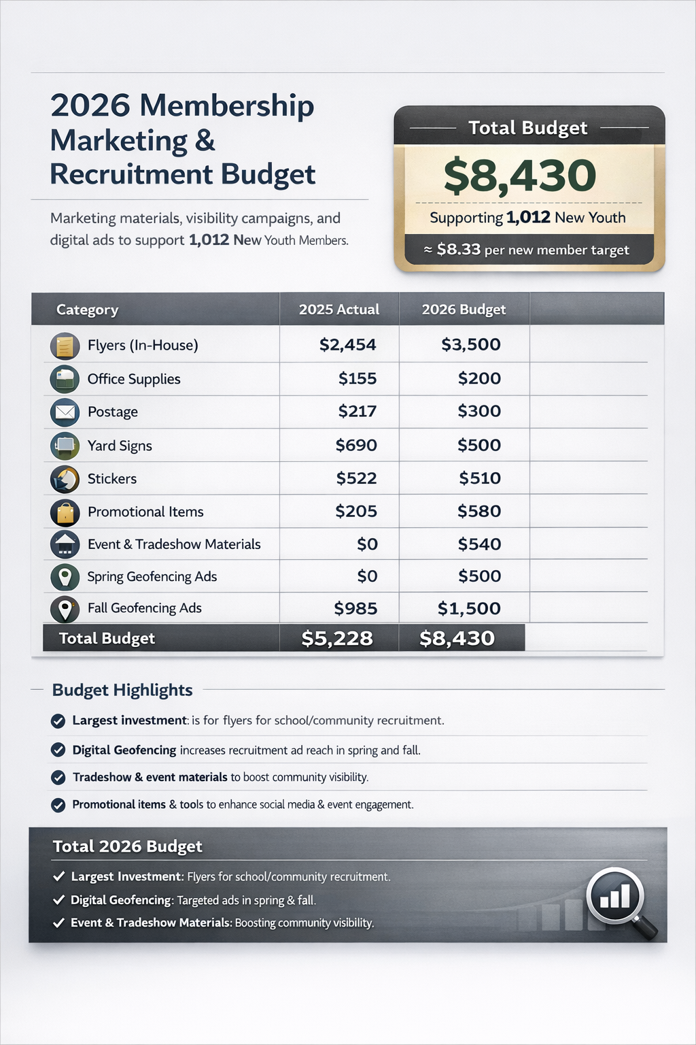

Council Market Analysis Report, Minsi Trails Council, BSA Research & Strategy, 2025
Older Youth – Venturing, Sea scouts, and post level Exploring.
Council 502 2026 TAY, National Council
Mosaic Segment Guide, Experian, 2025.

