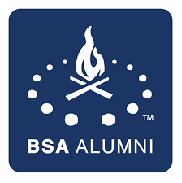

Minsi Trails Alumni Scholarship

2023 Eagle Scout Vo-Tech Award

Congratulations to all of the 2023 Eagle Scouts on a job well done! The Alumni Committee of Minsi Trails Council will be offering a $1,000.00 Scholarship to one Eagle Scout for use in attending an approved Vo-Tech School. A letter from the Eagle Scout who’s planning to attend a Vo-Tech School must be submitted by April 18th, 2024 for consideration.

Requirements to be considered for the Scholarship:

- Must be attending or accepted at an approved Vo-Tech School for the year 2024.
- Must have a letter in his/her own handwriting stating why this should be awarded to you, the Eagle Scout
- Must have a letter of acceptance from the Vo-Tech School
- Explain why becoming an Eagle will help you achieve your goals in the field you have chosen.
Please make your submission to coo@minsitrails.org. Good Luck in the field of your choice and may you find the field rewarding in your future. Good luck on being chosen to receive the scholarship.

The Minsi Trails Alumni Committee

